What is Linear Algebra?

**Linear Algebra** is the branch of mathematics that deals with **vectors**, **matrices**, and **linear transformations** between vector spaces.

What is a Vector?

A **vector** is an **ordered list of numbers**, which can represent things like:

* Direction and magnitude in space (physics)
* Data points (machine learning)
* Coordinates (math/geometry)

Mathematically, a vector is written as:

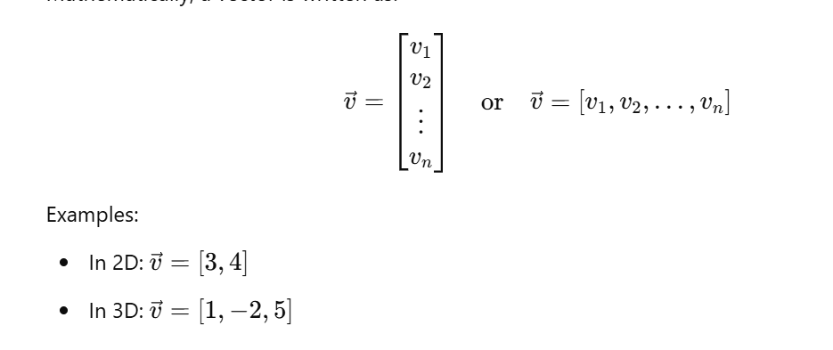

Vector Types:

1. **Row Vector**: 1 × n matrix → [v1,v2,…,vn]
2. **Column Vector**: n × 1 matrix → same as above but vertically stacked
3. **Zero Vector**: All elements are 0 → [0,0,…,0]
4. **Unit Vector**: Magnitude is 1

Vector Operations:

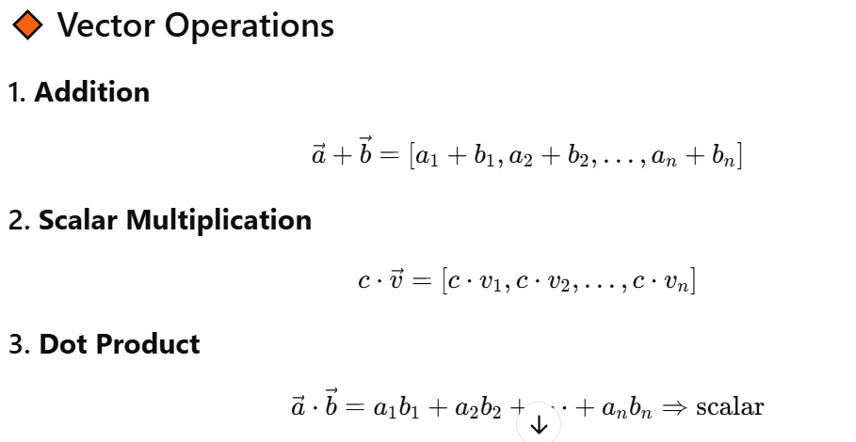

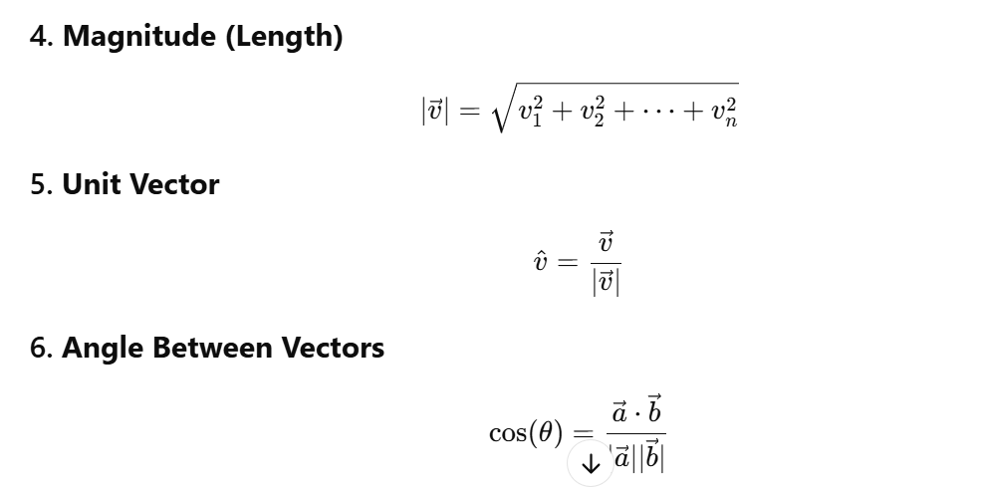

Geometric Interpretation:

In 2D/3D, a vector represents an arrow:

* **Direction** = direction of the arrow
* **Magnitude** = length of the arrow

For example, [3,4] points to the position (3,4) from the origin and has length.

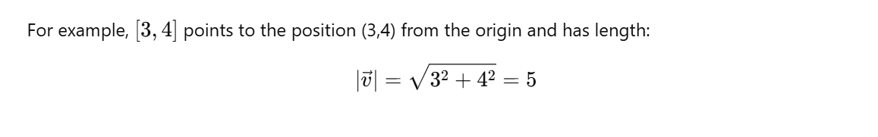

Linear Combination:

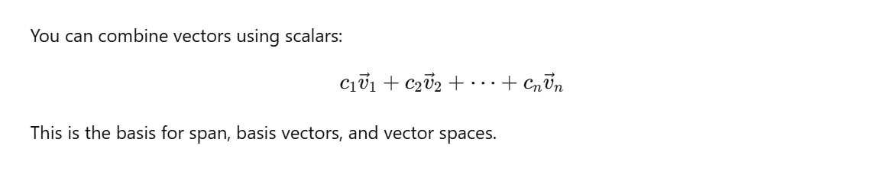

Inner Product (Dot Product):

The **inner product** is a generalization of the **dot product**, which measures similarity between two vectors.

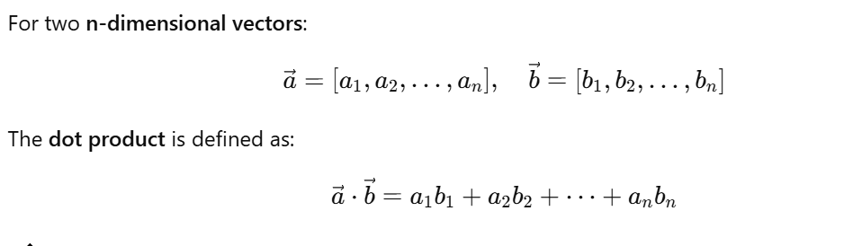

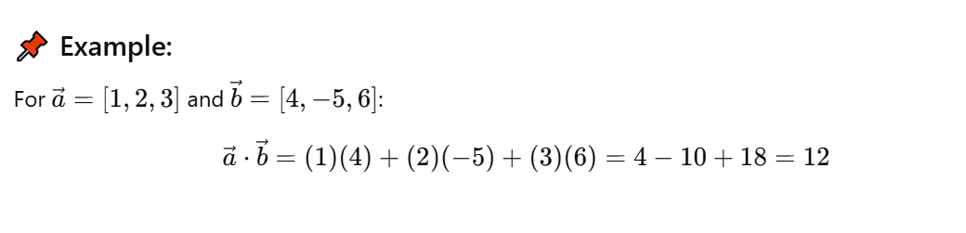

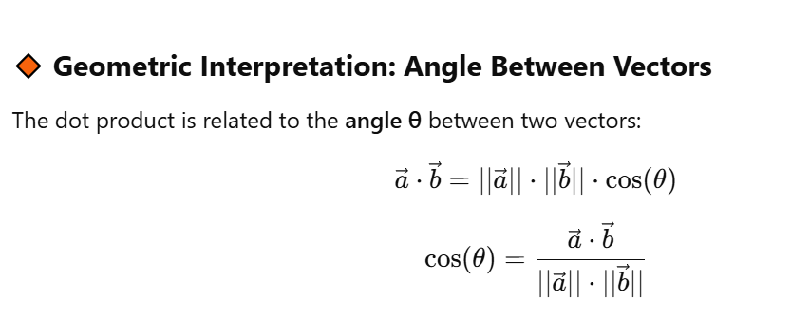

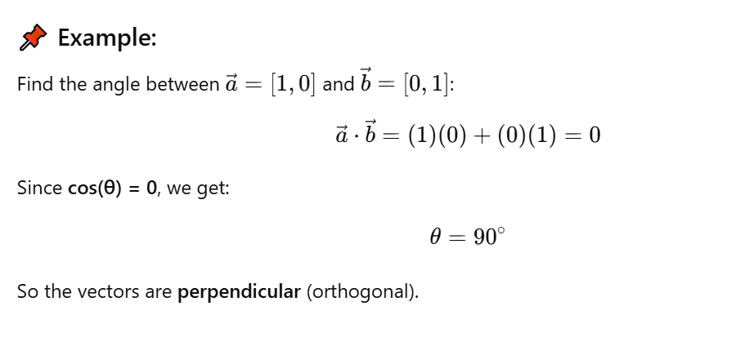

**Properties of the Dot Product:**

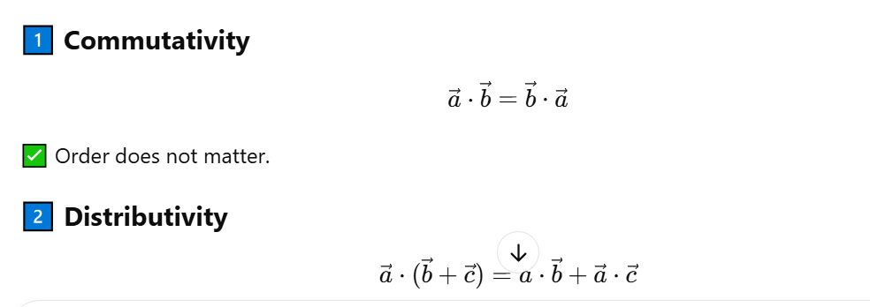

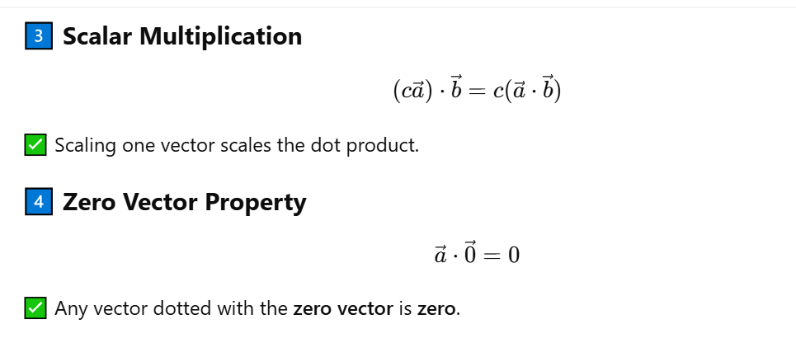

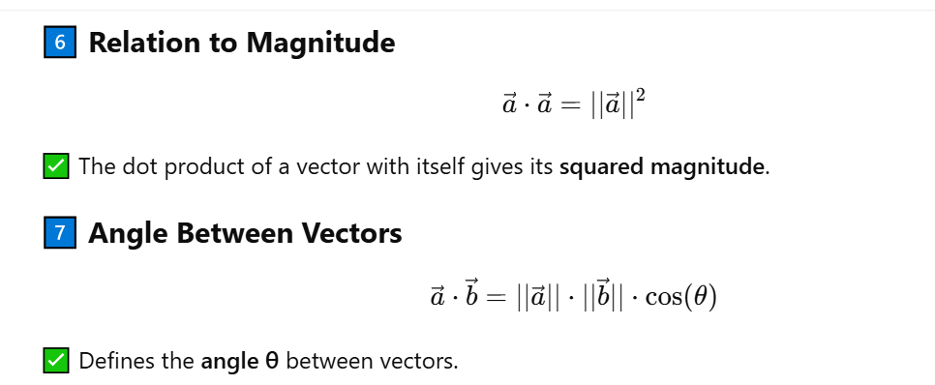

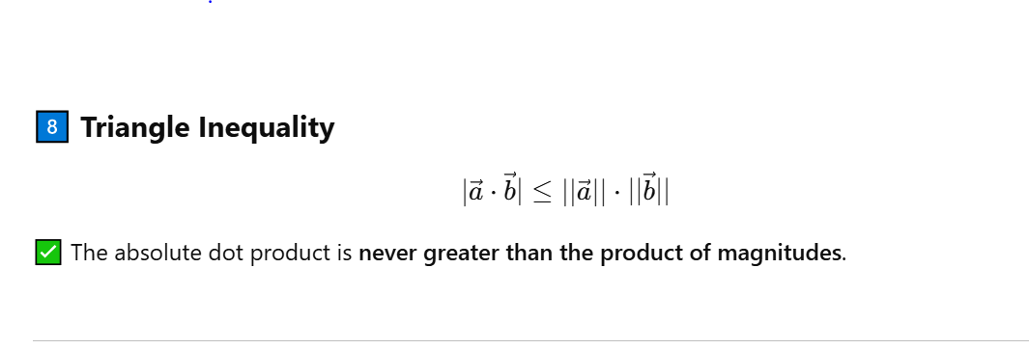

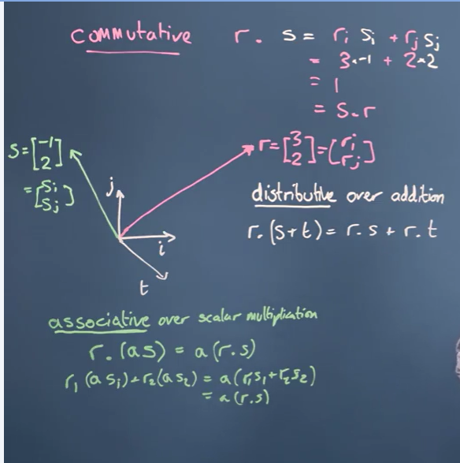

Dot Product of a Vector with Itself:

For a vector **a** in n-dimensional space:



This is simply the **sum of the squares of its components**.

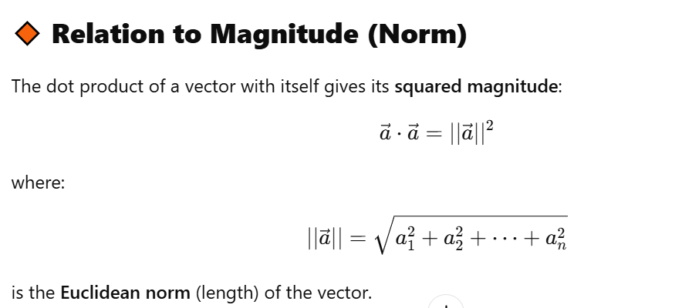

Special case:

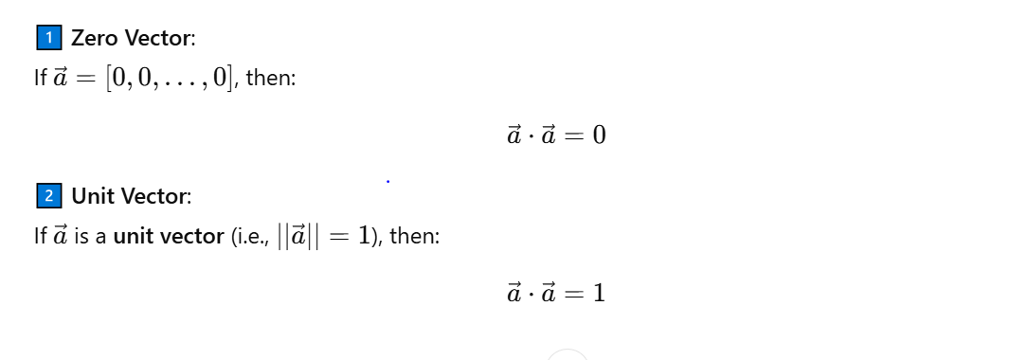

Projection:

In **linear algebra**, a **projection** is the process of mapping a vector onto another vector or a subspace. The result is a new vector that lies on the target vector or subspace, representing the component of the original vector in that direction.

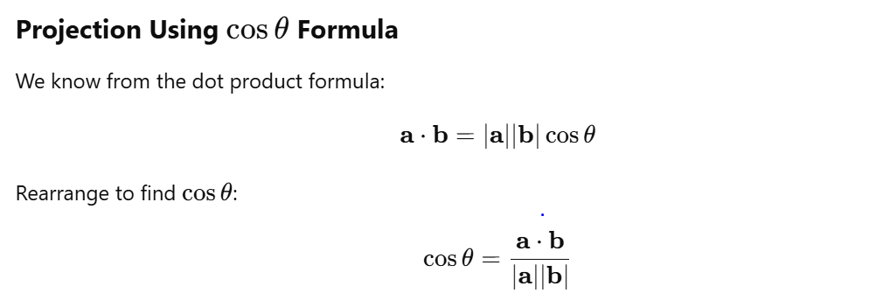

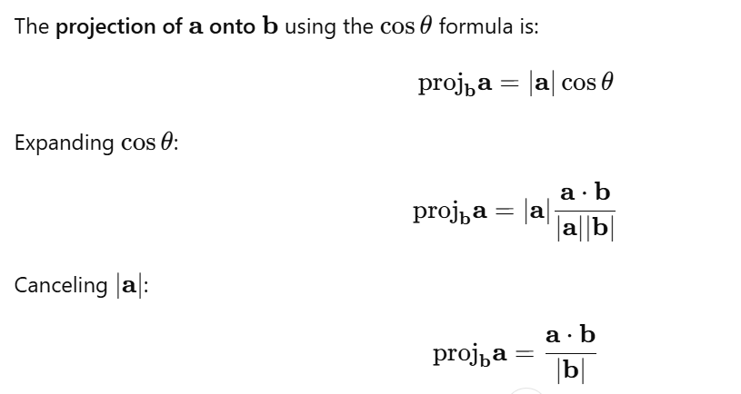

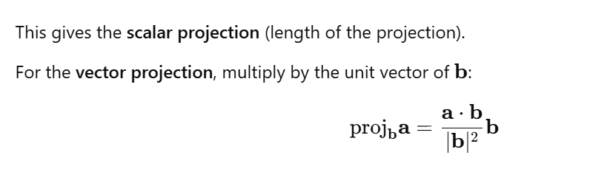

Example:

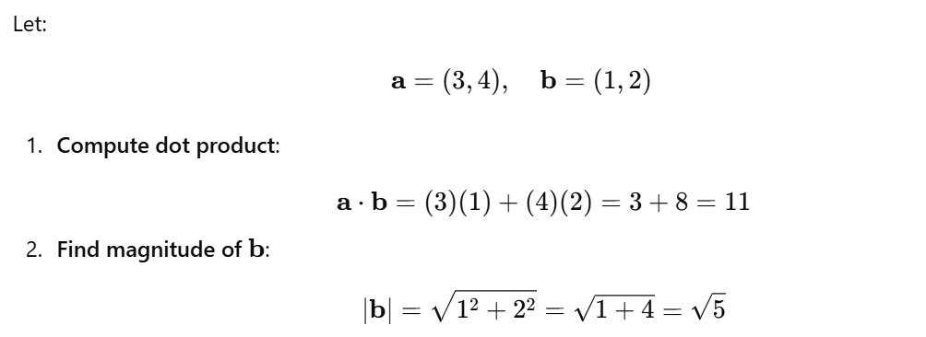

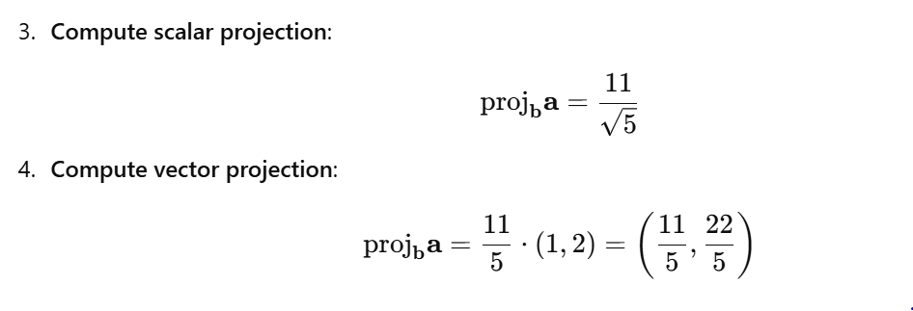

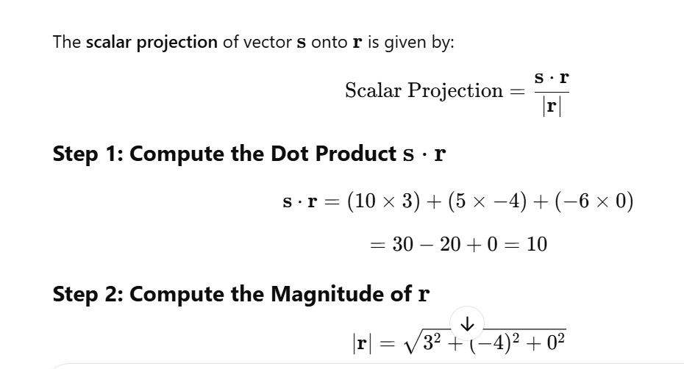

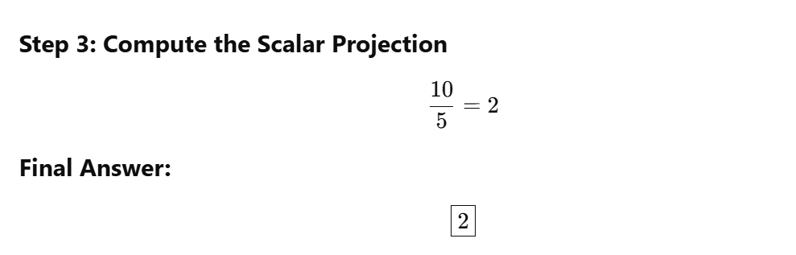

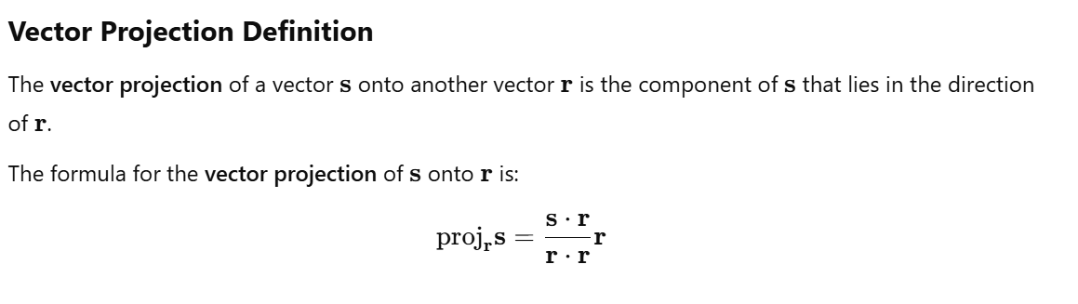

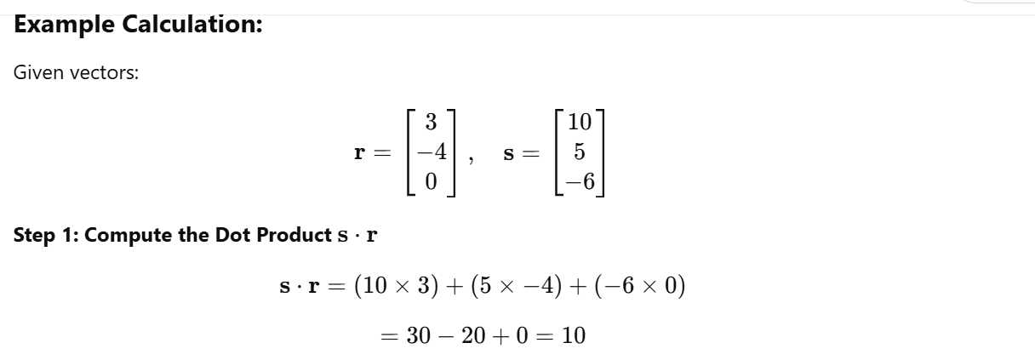

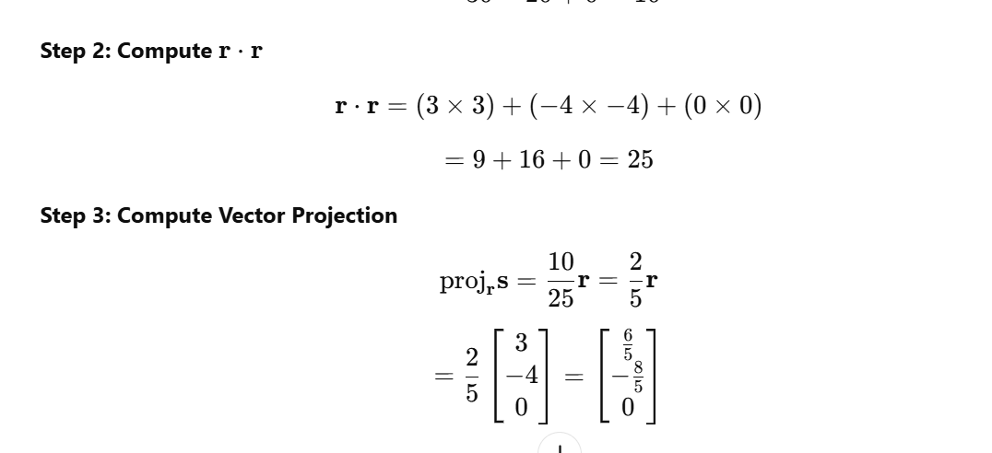



Changing Basis:

**Changing basis** means expressing a vector or a system of vectors in terms of a new set of basis vectors instead of the original ones.

In simpler terms, it’s like translating coordinates from one language (basis) to another while preserving the meaning (vector itself).

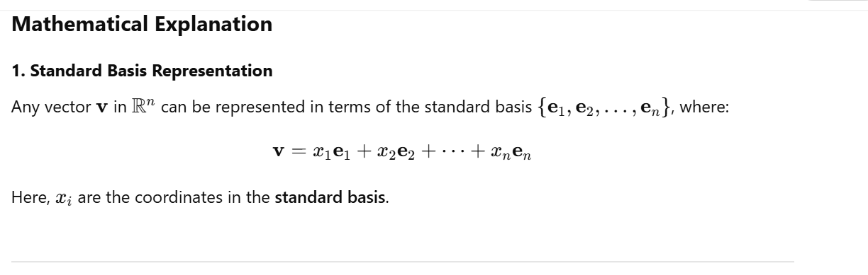

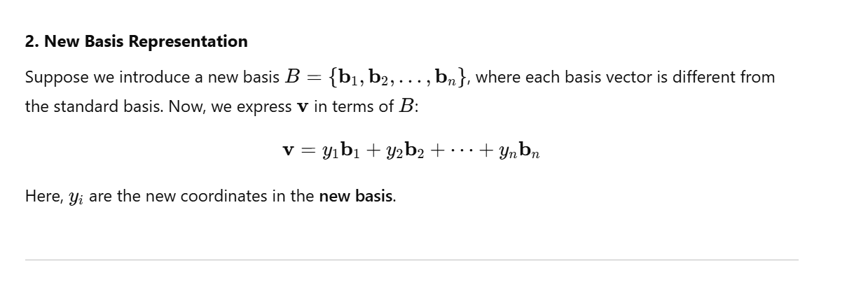

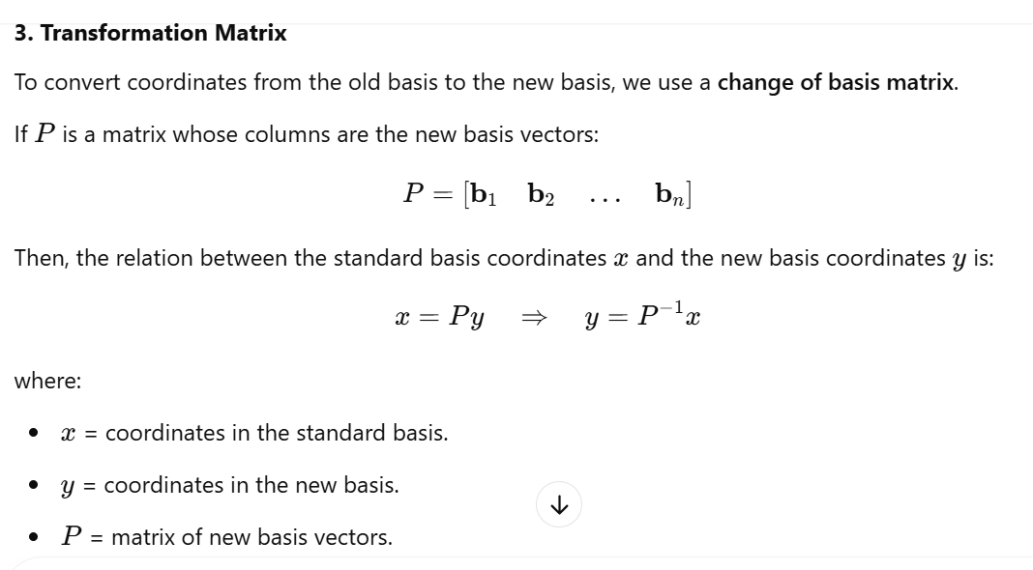



Example of basis change:

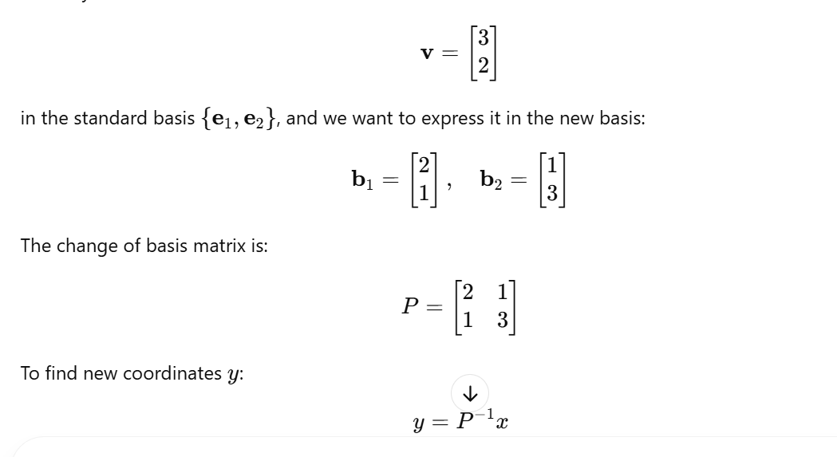

Vector space:

A **vector space** is a collection of vectors that can be added together and multiplied by scalars while following certain mathematical rules. It consists of:

* A set of vectors
* A set of scalars (from a field, e.g., real numbers R\mathbb{R}R)
* Two operations: **vector addition** and **scalar multiplication**

#### **Example of a Vector Space:**

* The set of all 2D vectors R2\mathbb{R}^2R2
* The set of all polynomials of degree ≤ 2

For example, in R^2 vectors like

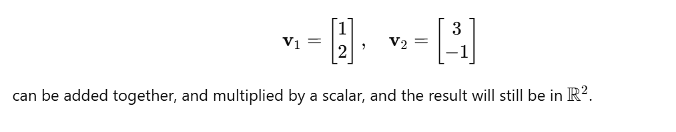

Basis :

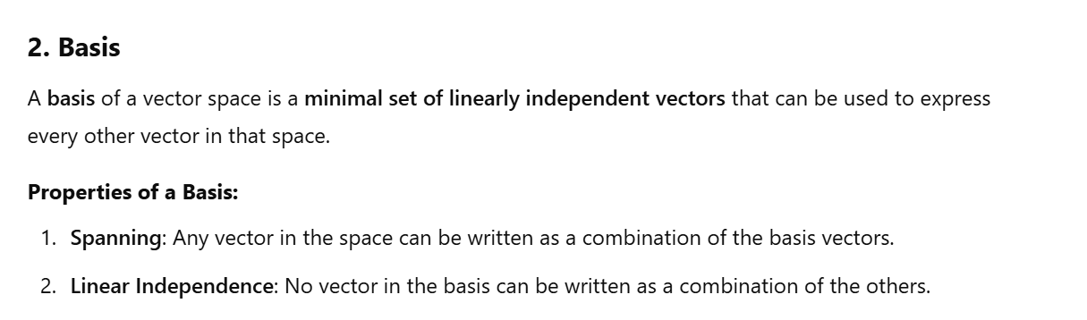

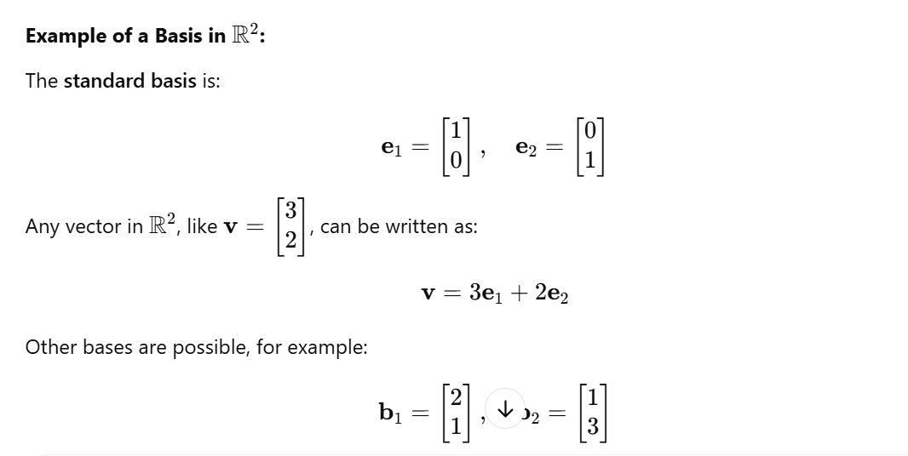

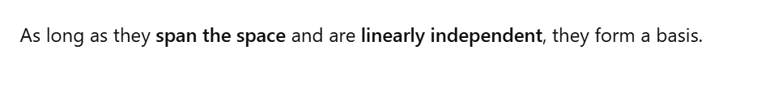

Linear Independence:

A set of vectors is **linearly independent** if none of them can be written as a combination of the others.

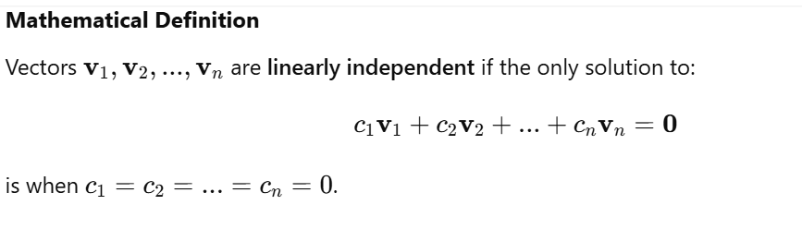

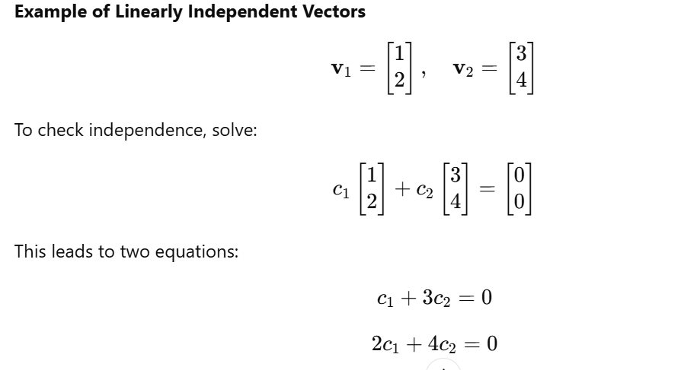  
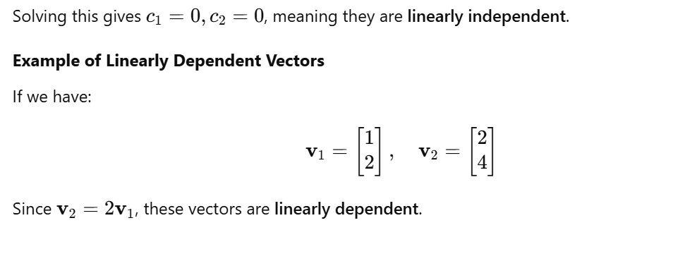

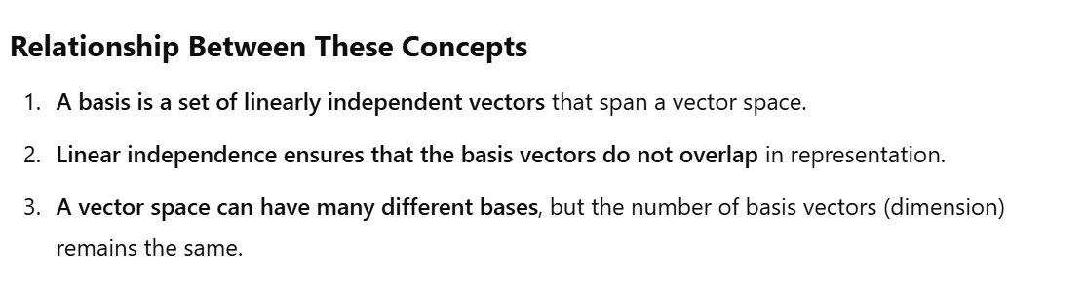

Transformation:

Matrices act as **transformations** that modify geometric spaces by rotating, scaling, reflecting, shearing, or projecting vectors. When a matrix A is applied to a vector v, the result is a new transformed vector:

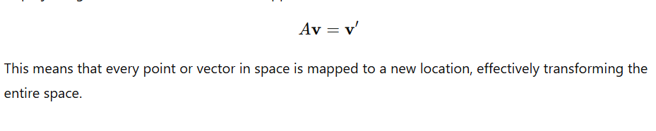

Types of Transformations by Matrices:

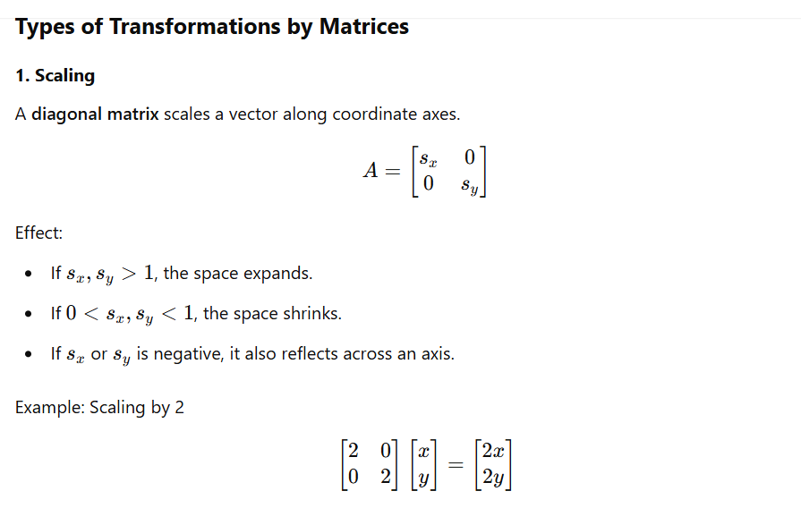

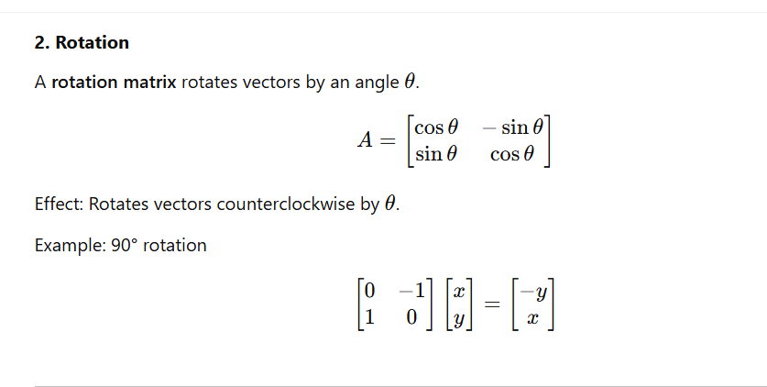

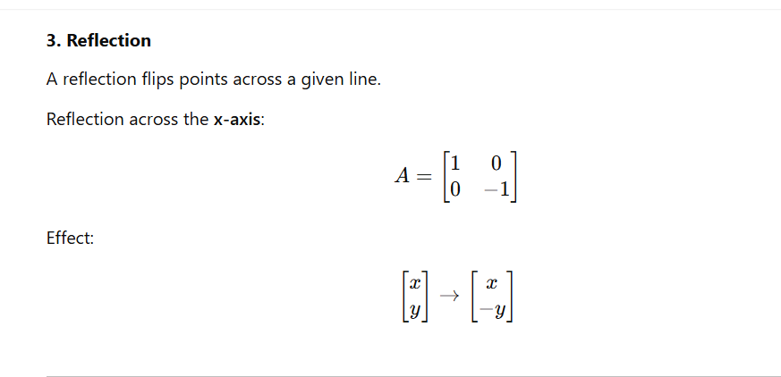

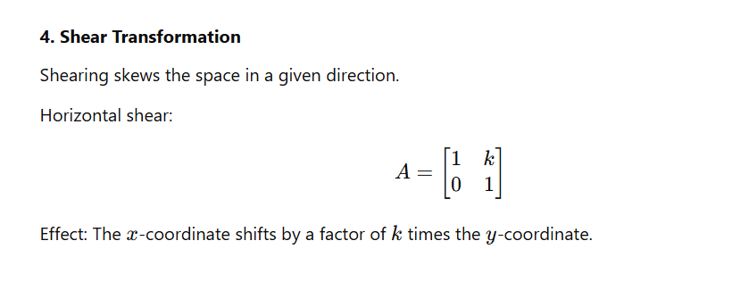

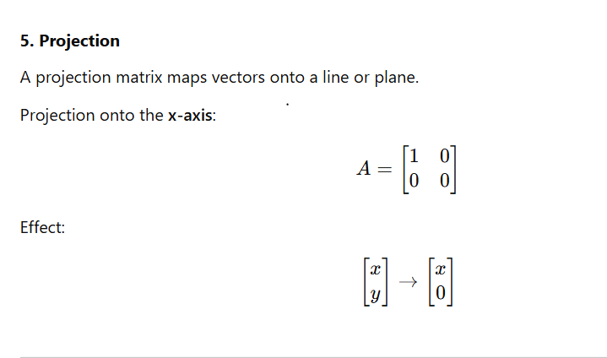

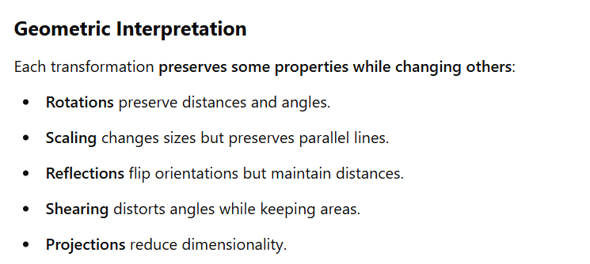

Composition and Combination of Matrix Transformations:

In **linear algebra**, we can apply multiple transformations sequentially using **matrix multiplication**. This process is called the **composition of transformations**. When two or more transformations are applied to a vector or space, their combined effect is represented by the **product of their transformation matrices**.

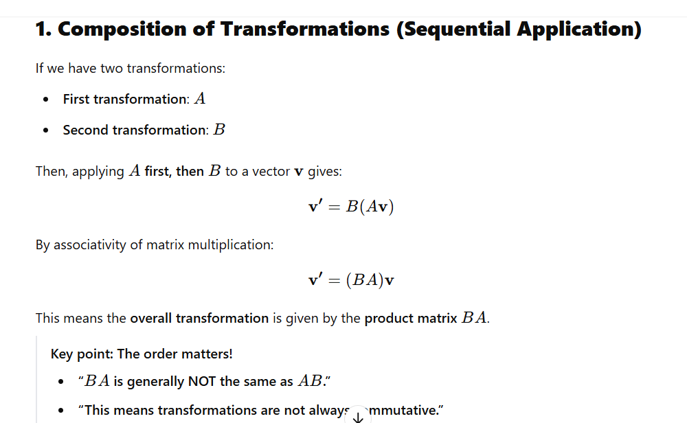

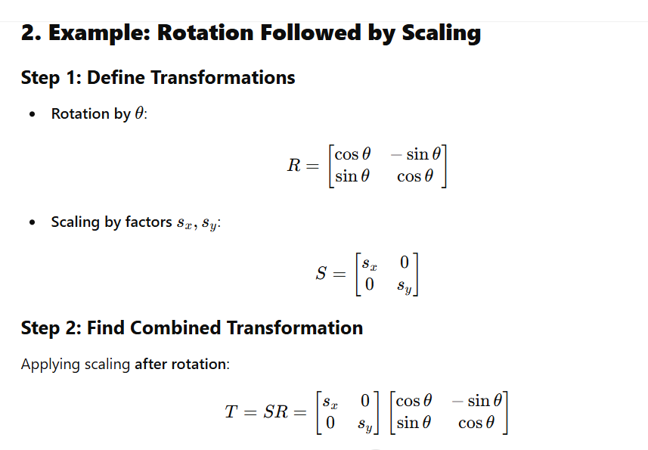

Gaussian Elimination Method:

**Gaussian elimination** is a method for solving systems of linear equations. It systematically transforms a system into an upper triangular or row-echelon form using elementary row operations, making it easier to solve.

#### **Purpose**

It is used for:

* Solving linear equations
* Finding the inverse of a matrix
* Determining the rank of a matrix
* Finding the determinant of a matrix

## **Steps in Gaussian Elimination**

1. **Convert the system into an augmented matrix**
2. **Use row operations to get an upper triangular (row-echelon) form**
   * Swap rows (if necessary)
   * Multiply a row by a scalar
   * Subtract multiples of a row from another row to eliminate variables

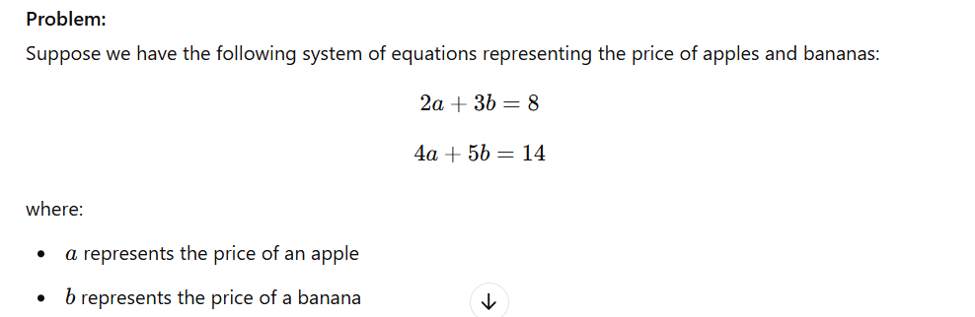

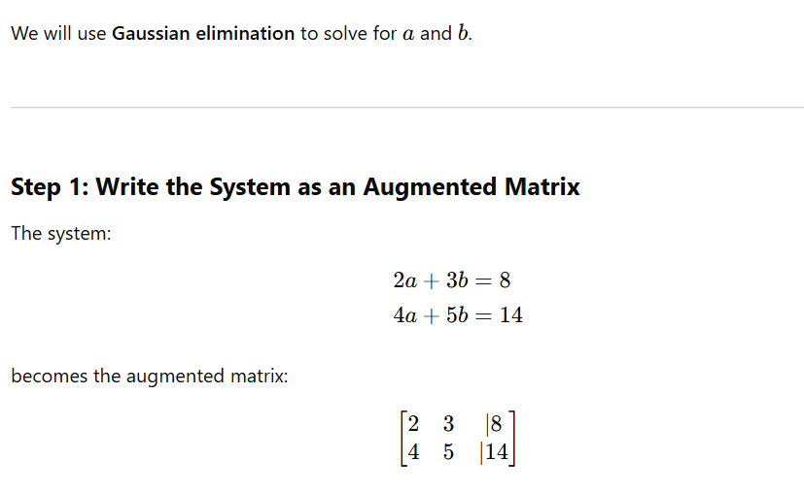

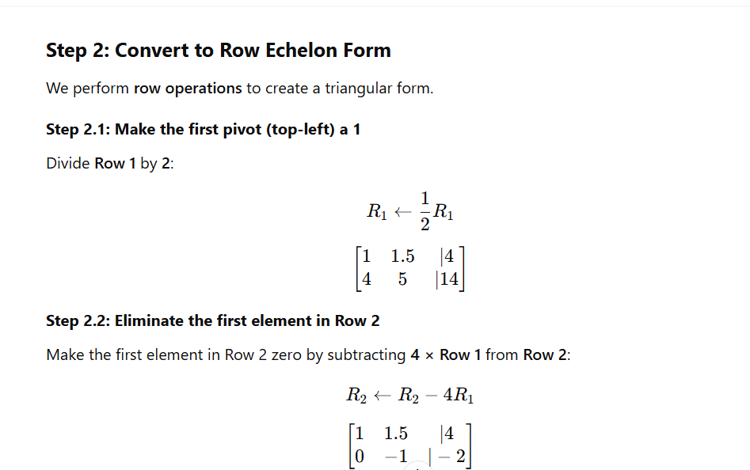

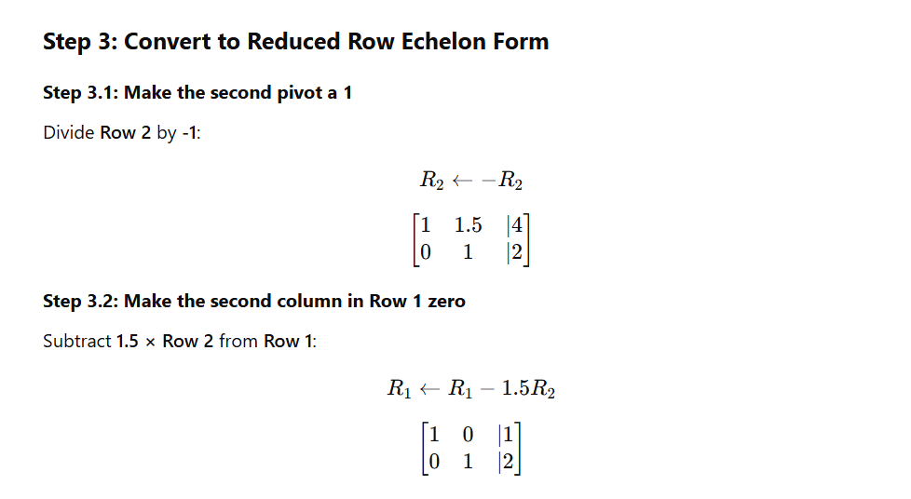

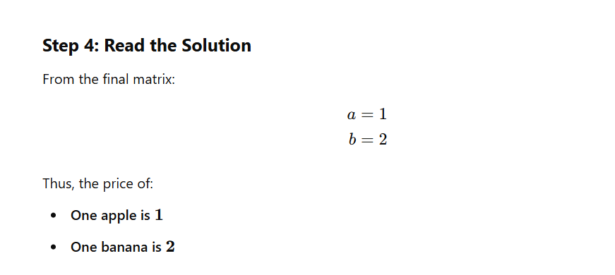

Row Echelon Form:

The **row echelon form (REF)** of a matrix is achieved by performing **row operations** to get a triangular-like structure with leading ones (pivots).

#### **Steps to Convert a Matrix to Row Echelon Form**

1. **Identify the leftmost nonzero column (Pivot Column).**
2. **Swap rows** (if necessary) to ensure the first row has a nonzero entry in the pivot column.
3. **Make the leading coefficient 1 (Pivot = 1).**
   * If the pivot is not 1, divide the row by the pivot value.
4. **Make all entries below the pivot zero** using row operations.  
   * Subtract multiples of the pivot row from lower rows.
5. **Move to the next column and repeat** for the remaining submatrix.

Example: Converting a Matrix to Row Echelon Form

Given matrix:



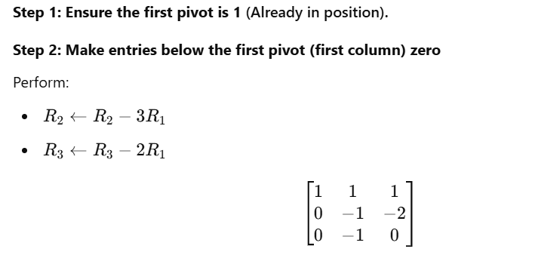

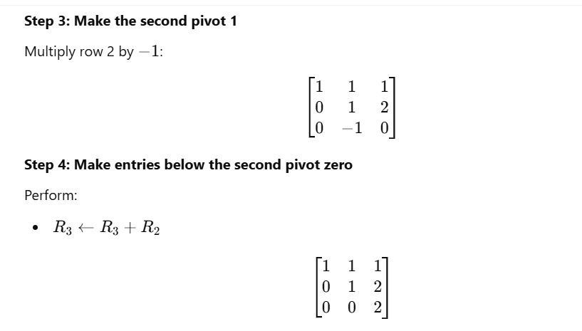

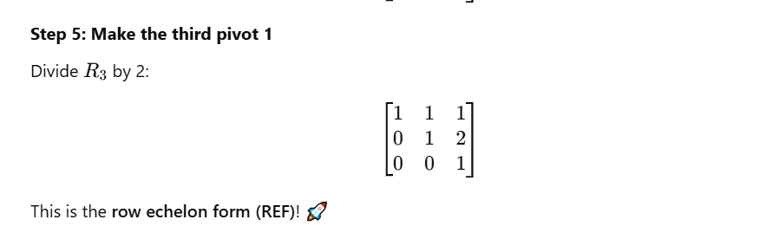

### **Use Cases of Row Echelon Form (REF)**

Row Echelon Form (REF) is a fundamental technique in **linear algebra** used in many real-world applications. Below some application are given:

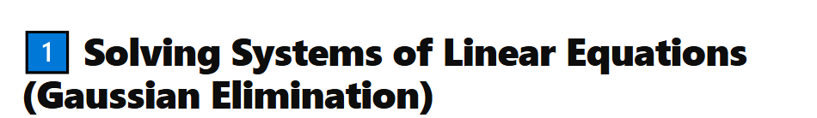

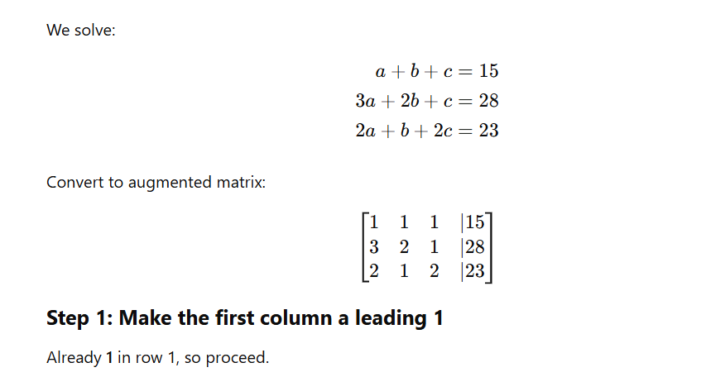

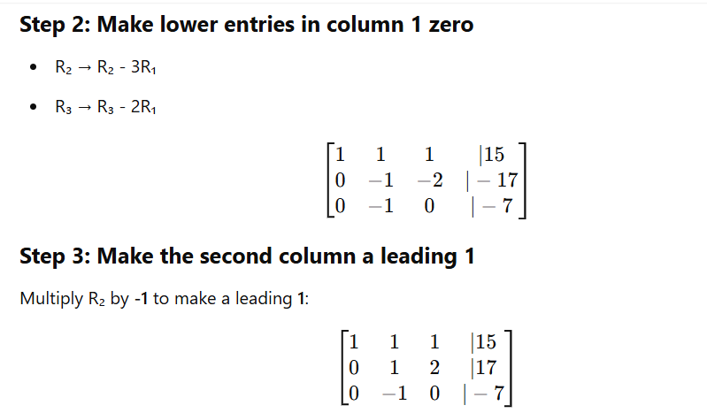

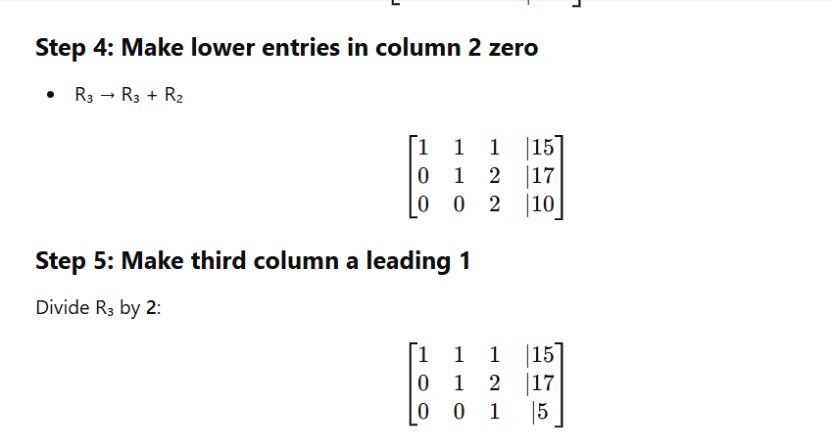

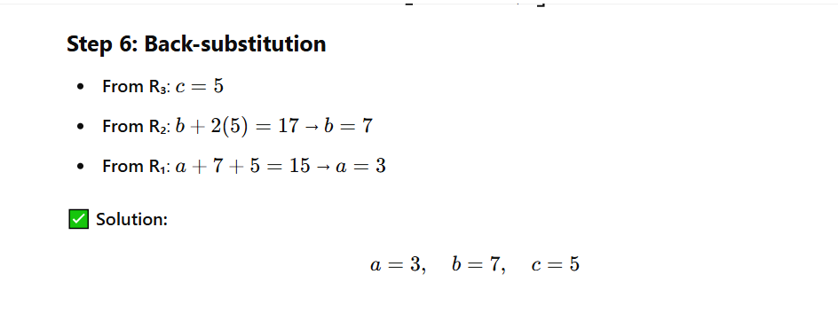

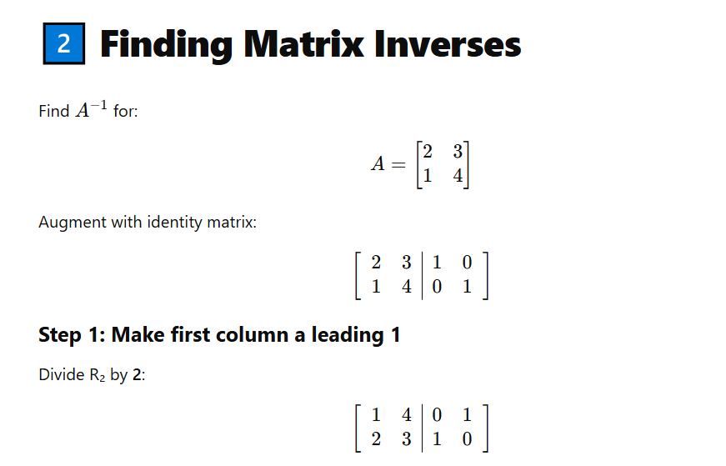

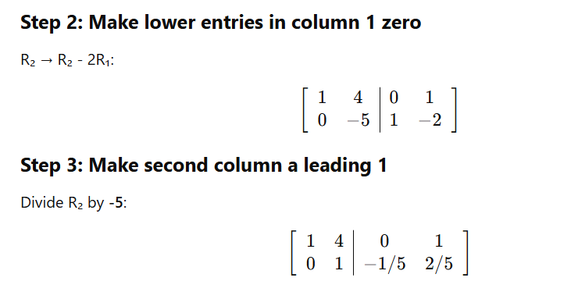

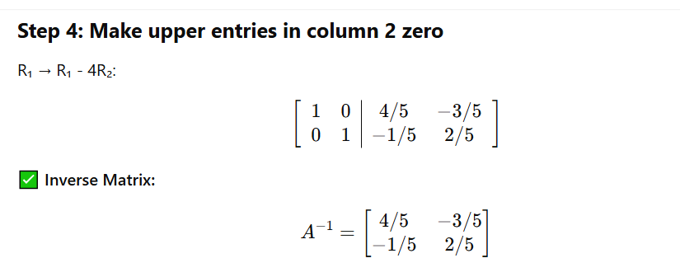

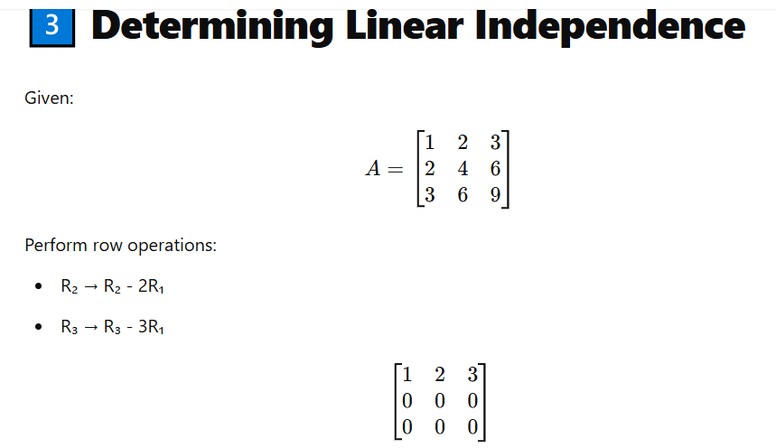

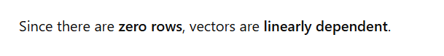

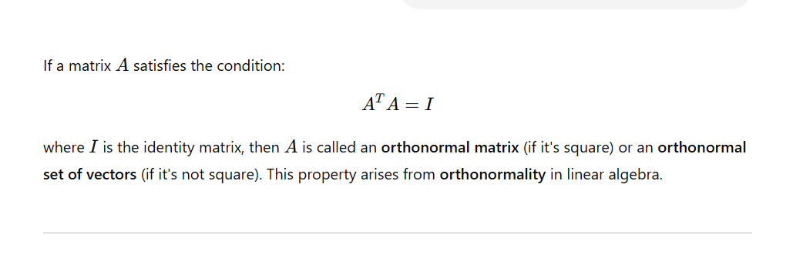

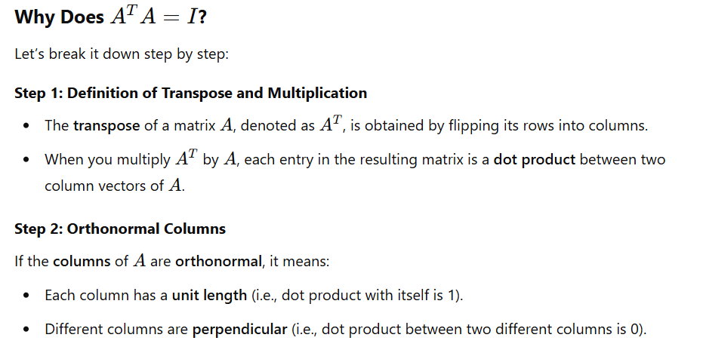

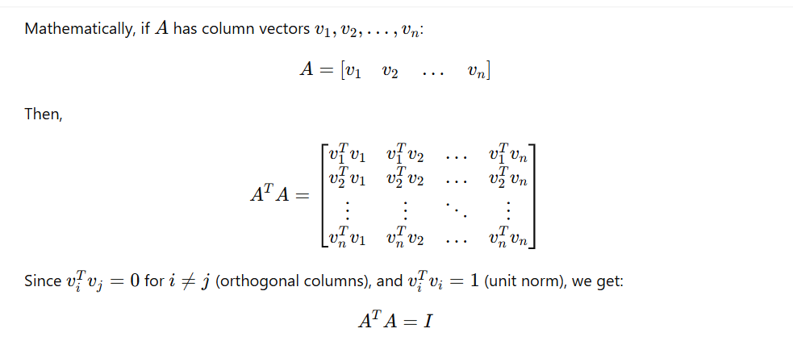

Eigenvalues and Eigenvectors :

Eigenvalues and eigenvectors are fundamental concepts in **linear algebra**, commonly used in areas such as **machine learning, quantum mechanics, and computer vision**.

What is an Eigenvector?

An **eigenvector** of a square matrix A is a **nonzero vector** v that **does not change its direction** when multiplied by A. Instead, it only gets **scaled** by some scalar λ:

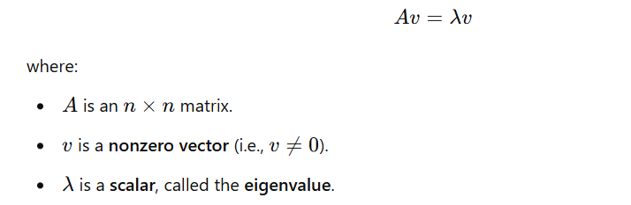

What is Eigenvalue?

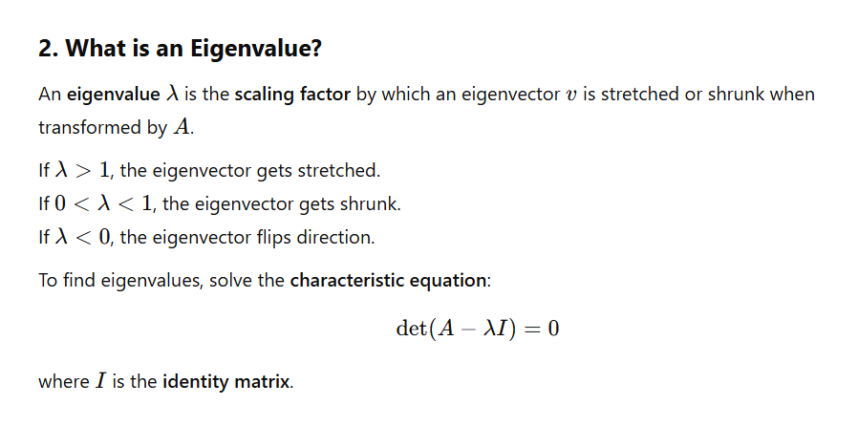

Eigenvalue and Eigenvector only possible in square matrix?



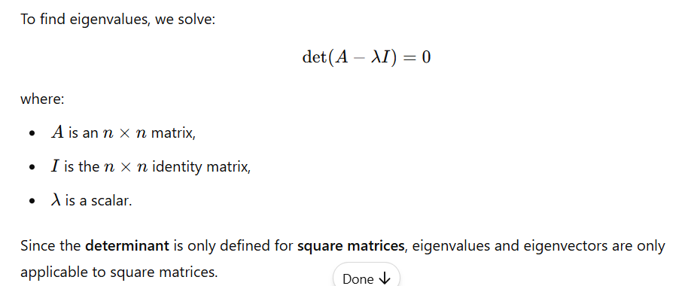

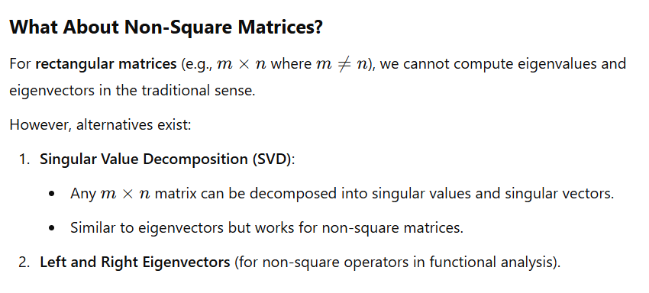

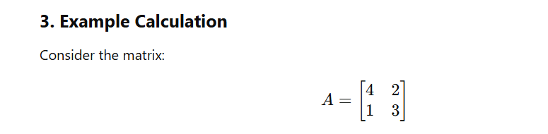

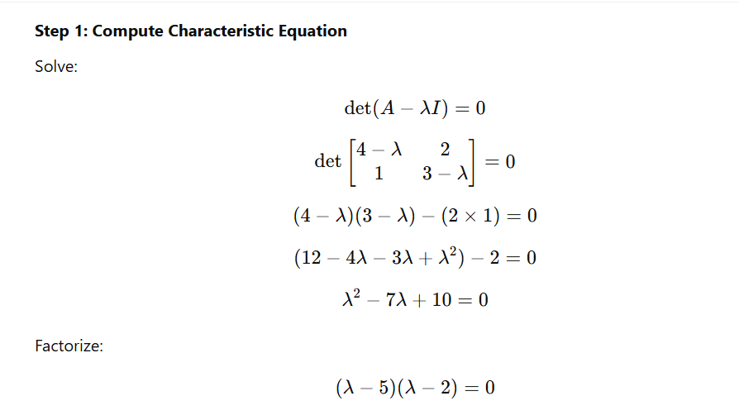

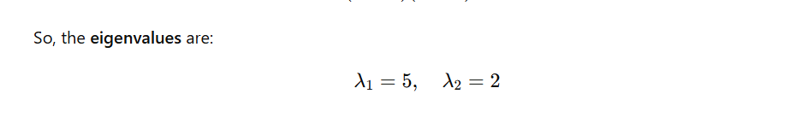

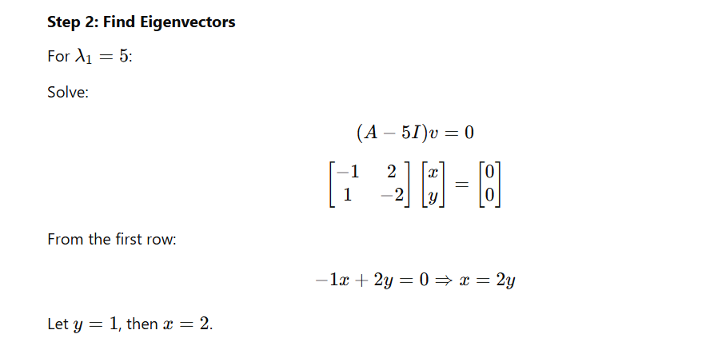

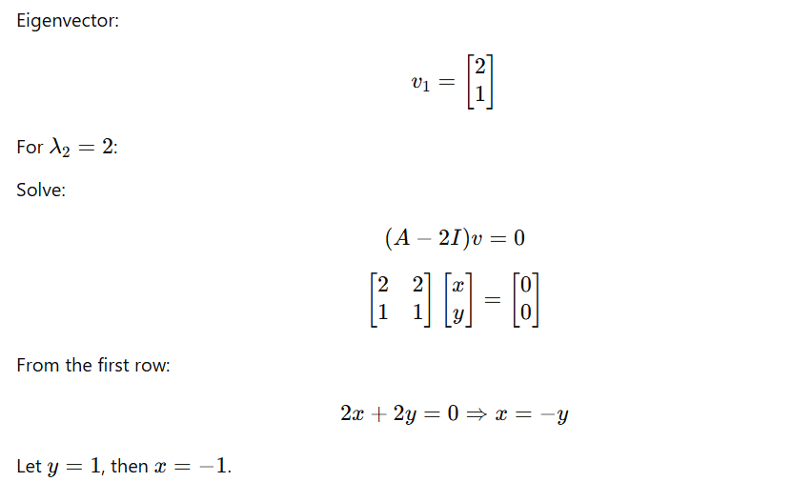

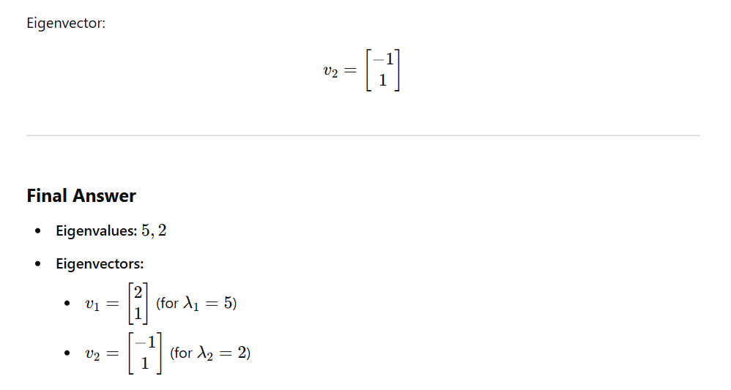

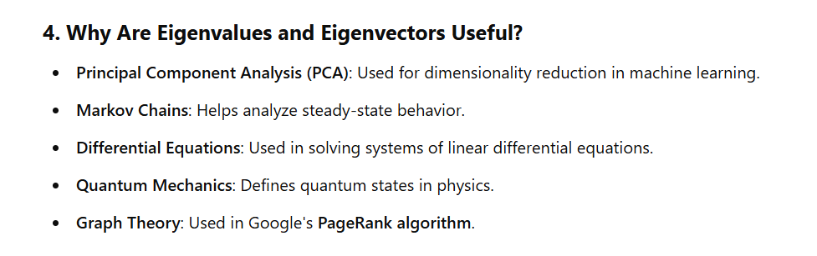

**\* * \***



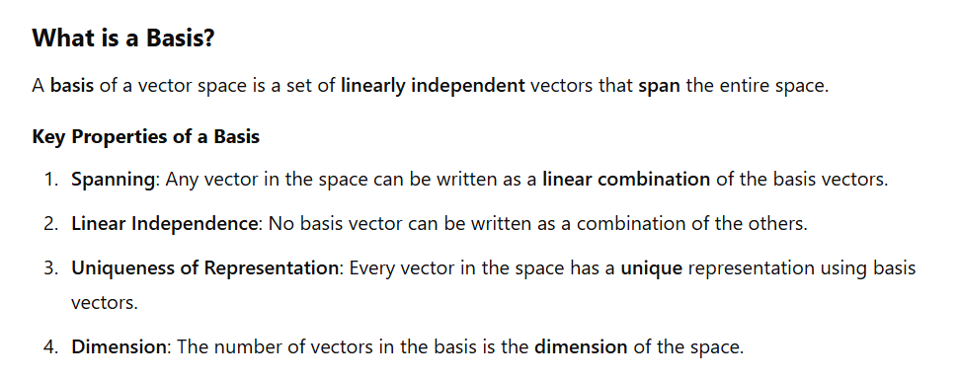

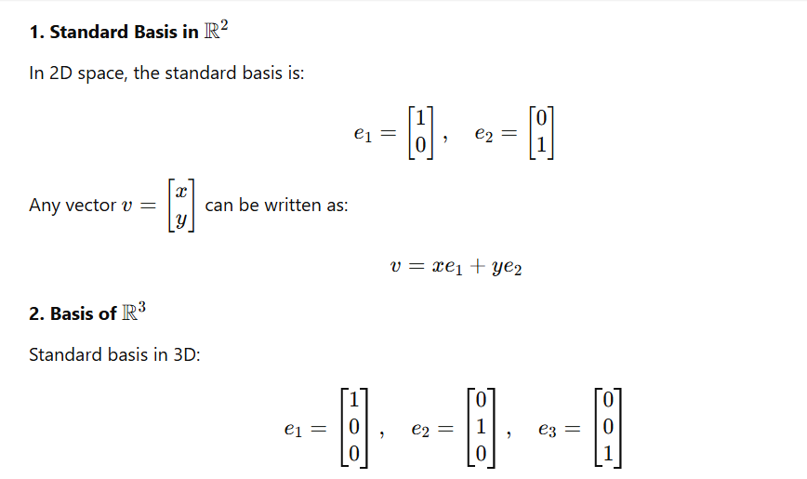

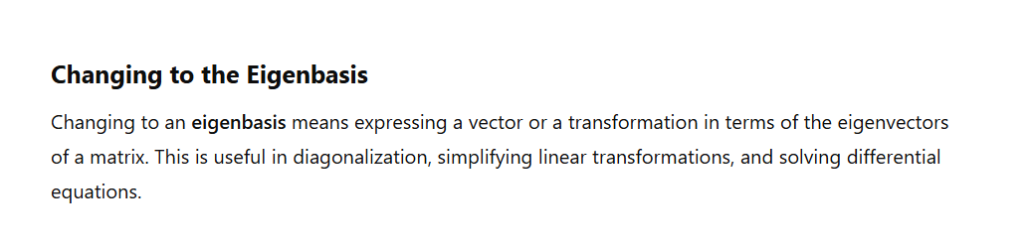

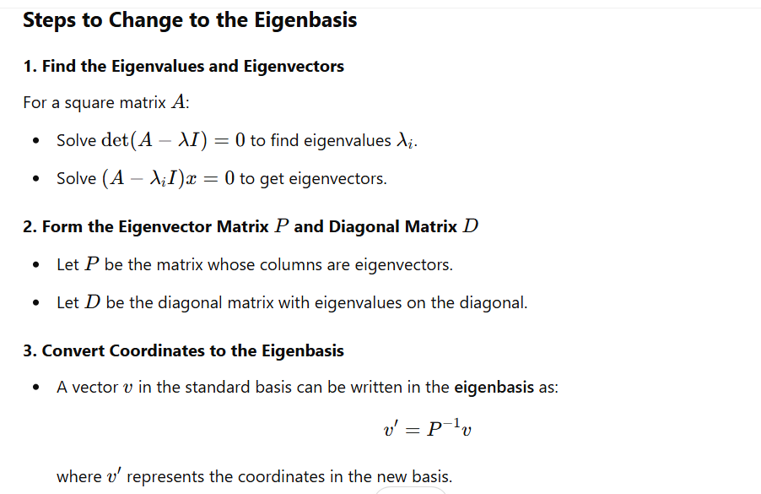

Eigenvector:

